1.

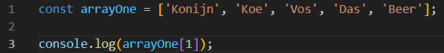



2.



3.



4.

5.

6.

